# 

# Hydrofoil Development Report

Aquantis, Inc.

101 E. Victoria Street, Suite F

Santa Barbara, CA 93101  
Tel. +1 805 845 7575

Fax +1 805 845 7266   
aquantistech.com

Authors

Henry Swales, Aquantis Inc.

Case Van Damn, Senta Engineering

Henry Shiu, Senta Engineering

|  |  |  |  |  |
| --- | --- | --- | --- | --- |
| Rev # | Description of changes | Rev Date | Revised By | Pages |
| 1.0 | Draft v1.0 | 6/17/2014 | Swales | All |
|  |  |  |  |  |
|  |  |  |  |  |
|  |  |  |  |  |
|  |  |  |  |  |

Table of Contents

Hydrofoil Development Report 1

Table of Figures 3

Table of Tables 3

1 Introduction 4

1.1 Nomenclature 4

2 Hydrofoil Design Progress 5

2.1 Phase 1: Baseline Comparison 5

2.2 Phase 2: MHK Outboard Foil Design Optimization 8

3 Hydrofoil Testing Progress 9

4 Project Schedule Update 10

# Table of Figures

Figure 1: NREL s816, s817, s818 5

Figure 2: MHK-F1-180, 240, 400 5

Figure 3: NREL Foil Set Lift Polar Comparison 6

Figure 4: XFOIL Comparison of NREL s817 (16%) to MHK-F1-180 (18%) 7

Figure 5: XFOIL Comparison of NREL s818 (24%) to MHK-F1-240 (24%) and HQ-57 (24.7%) 7

Figure 6: MKH-F1 RaNS CFD Analysis Compared to XFOIL 8

# Table of Tables

Table 1: Project Schedule 10

# Introduction

This update covers the first phase of hydrofoil development in cooperation with Senta Engineering. This phase involved comparing the MHK-F1 foil set to the NREL large-wind turbine foil set used on previous Aquantis rotor designs.

## Nomenclature

α angle of attack

CFD computational fluid dynamics

C chord length

Cd sectional drag coefficient

Cl sectional lift coefficient

Cl0 sectional lift coefficient at zero degrees angle of attack

Cpmin minimum pressure coefficient

l/d lift to drag ratio

l/dmax maximum lift to drag ratio

M∞ freestream Mach number

MHK marine and hydrokinetic

m meters

m/s meters per second

ncrit transition prediction parameter

p pressure

pv vapor pressure

p∞ freestream pressure

ρ density

ρ∞ freestream density

R rotor radius

RaNS Reynolds-averaged Navier Stokes

Re Reynolds number

σ cavitation number

# Hydrofoil Design Progress

## Phase 1: Baseline Comparison

The MHK-F1 foil set is substantially different from the NREL s816 foil set both in geometry and performance. The two foil sets are shown below in Figures 1 and 2.

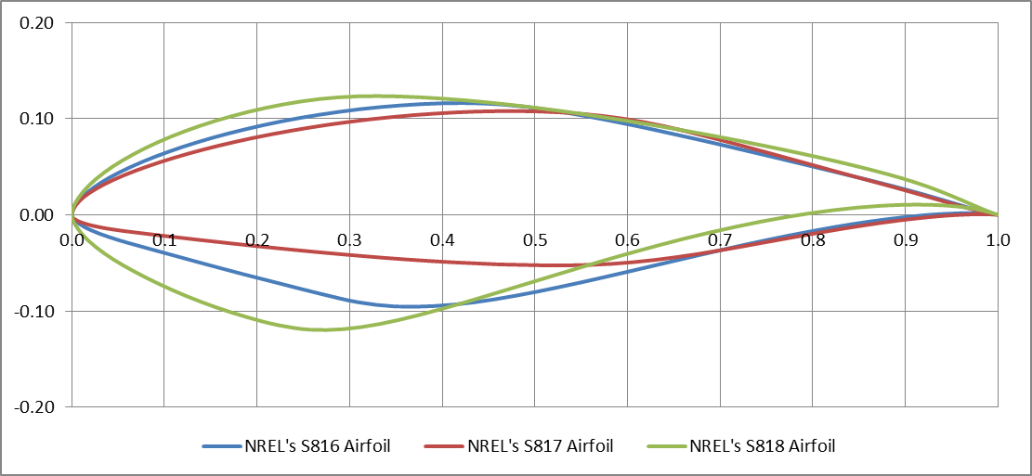

Figure 1: NREL s816, s817, s818

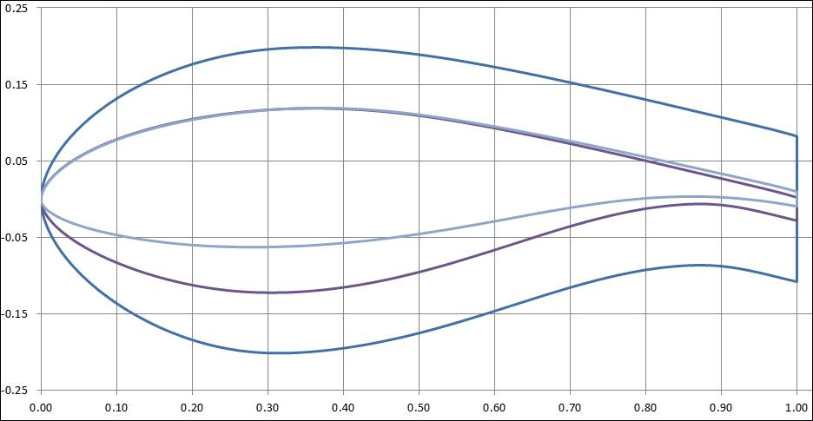

Figure 2: MHK-F1-180, 240, 400

The NREL foils range in thickness from 16 to 24% t/C, whereas the MHK-F1 foil set ranges from 18% to 40% t/C, thereby providing much greater structural efficiency. Utilization of modern flat-back foil design on the inboard foils enables this structural efficiency while minimizing the impact on rotor performance. Many of differences in design objectives between the two foil sets can also be readily seen in the geometry. The NREL foils have a sharp leading edge to restrain max lift for stall regulation; the MHK foils have a rounded leading edge to restrain Cpmin for cavitation considerations. The MHK foils have substantially thicker trailing edges for both anti-singing considerations and structural considerations.

Both foils sets were designed to extend the laminar boundary layer though the implementation of a constant pressure gradient on the forward portion of the low pressure surface. However, the center of thickness of the NREL foils varies greatly across the foil set as does the low pressure surface geometry and the amount of camber (in particular in the region of the high pressure trailing edge surface). The result of these features is a shift in Cl0, which will cause a shift in twist and/or chord on the rotor blade. Combined with the other geometry inconsistencies across the family, the NREL foil set becomes very challenging for blade lofting, which also results in an impact on rotor performance.

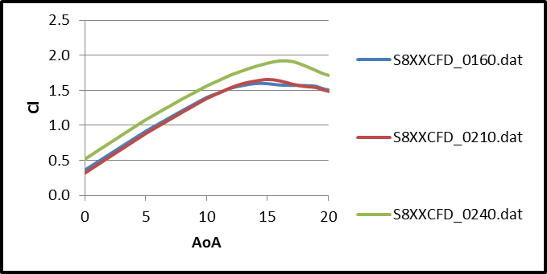

Figure 3: NREL Foil Set Lift Polar Comparison

By comparison, the MHK-F1 foil set maintains almost identical low pressure surface geometry and max thickness location, which results in consistent (or at least smooth transitions) of key aerodynamic metrics for rotor blade design such as (Cl0, camber, Clmax, Stall Angle, Trailing Edge Thickness, Max Thickness Location). Many of these can be seen in the performance plots on the following discussion.

In terms of performance, the two foils sets are also markedly different. In general, the MHK-F1 foil set does have lower L/D; however, this is largely due to the increase trailing edge thickness which would likely also have to be implemented on the NREL foils for a successful blade design. The higher L/Dmax of the NREL foils also comes at the cost of a narrower drag bucket, and very ‘peaky’ L/D curve, meaning off-design performance will suffer greatly. The L/D of the 16% NREL foil also peaks at a fairly low Cl (0.7), which means this will result in fairly large chord length on the outer portions of the blade.

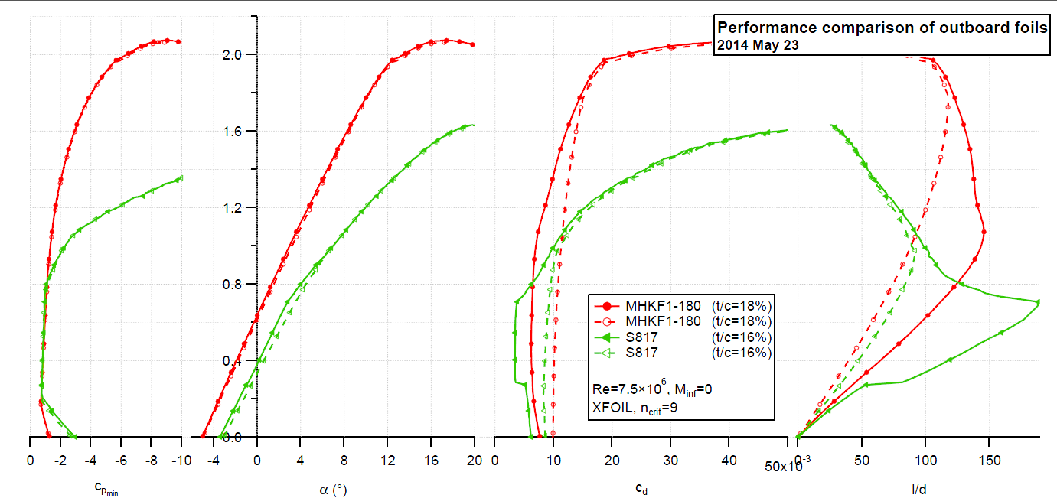

Figure 4: XFOIL Comparison of NREL s817 (16%) to MHK-F1-180 (18%)

It can be observed in the XFOIL plots above and below that the Cpmin of the MHK-F1 foil set remains much lower than the NREL foils over the complete range of operation for both the 18% and 24% foils. The reduction in performance resulting from soiled conditions (BL tripped within 5% of LE HP & LP) is also greater on both the NREL foils.

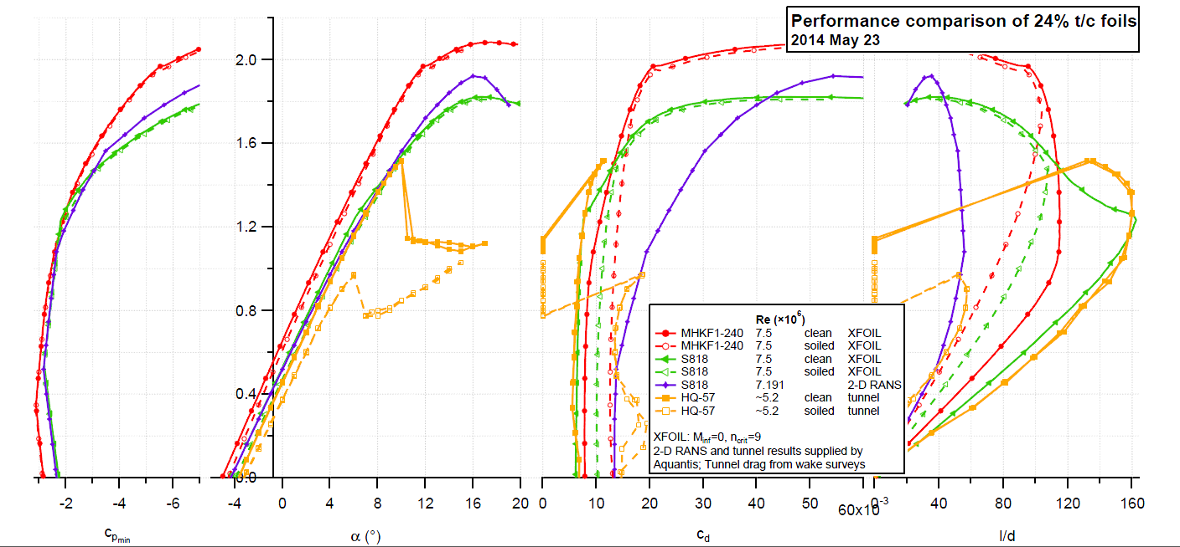

Figure 5: XFOIL Comparison of NREL s818 (24%) to MHK-F1-240 (24%) and HQ-57 (24.7%)

The plot below shows the MHK-F1 XFOIL results compared to RaNS CFD analysis. Although this shows a reduction in the in Cl at the start of stall, Clmax is appears to be significantly restrained on the both NREL foils when compared in XFOIL to the MHK-F1 foil set.

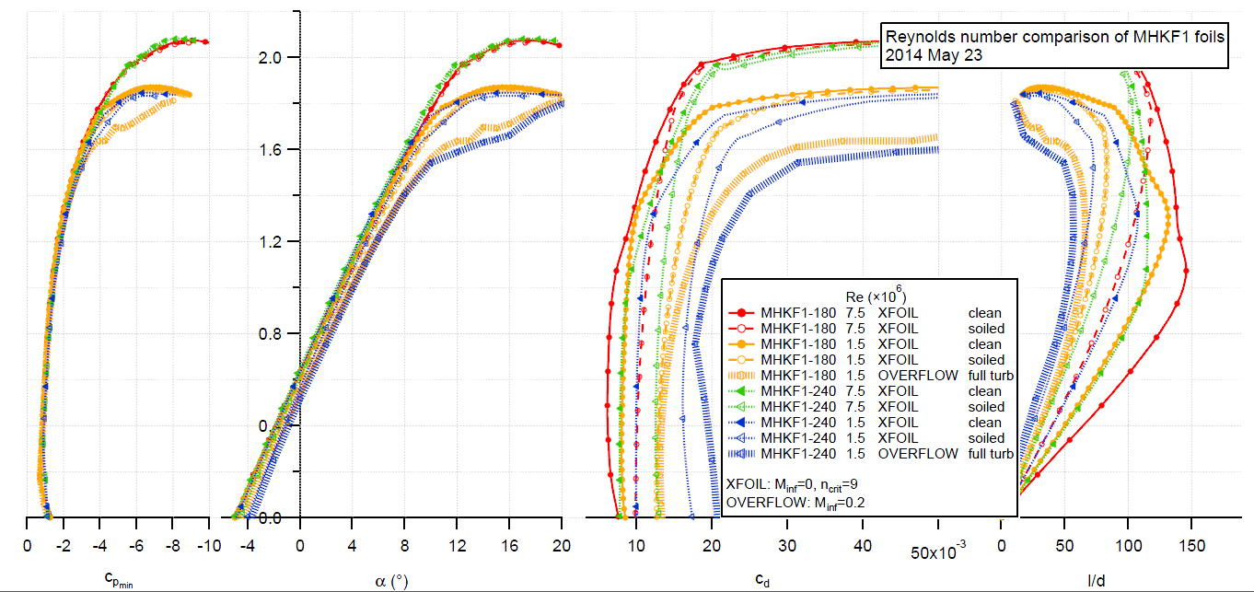

Figure 6: MKH-F1 RaNS CFD Analysis Compared to XFOIL

Many of the baseline design objectives are met by the MHK-F1 foil set. Depending on the application, at this point in time I would recommend using the MHK-F1 foil set in place of the NREL foils for use in on-going MHK rotor design efforts.

## Phase 2: MHK Outboard Foil Design Optimization

The next phase of hydrofoil development is focused on optimizing this foil set for larger ocean-current turbines operating at higher Re#.

The issue of restraining Clmax is being addressed first through the investigation of leading-edge stall strips. This is an attractive solution as it allows the foils to be configured either for stall-regulation or low-cavitation-susceptibility. It is useful to separate these two configurations as their design goals are conflicting; this is because a sharp leading edge leads to a high Cpmin which is used to trip the boundary layer and initiate an early stall thereby constraining Clmax.

The more robust boundary layer present at higher Re# (7.5e6 vs. 1.5e6 – the original MHK-F1 design Re#) may allow the MHK foils to be optimized to further extend the laminar flow portion thereby improving L/D. This potential improvement in L/D may come at the cost of a slightly more concentrated drag bucket and ‘peaky’ L/D curve.

# Hydrofoil Testing Progress

Discussions continue with NASA LRC regarding the feasibility of testing our desired conditions in the 0.3m TCT

Due to refurbishment efforts on the tunnel, the variable wall geometry jacks are not presently reliable enough for commercial testing. It is recommended we proceed with fixed divergent walls and utilize standard wall corrections. NASA LRC has developed wall corrections codes for this application, but some effort is required to bring the codes and appropriate personnel back into operation.

The first phase of testing would consist of a feasibility check of the tunnel operating at our desired conditions with an existing NACA 0012model. Results from this test will be compared with published NACA results from the Low Turbulence Pressure Tunnel. Uncertainty targets for these measurements and wall corrections are as follows:

Based on a lift coefficient range from approximately -1.0 to + 2.0, an uncertainty of ± 0.02 or less in lift coefficient would be acceptable. This is equivalent to about 1% of full scale.

The industry standard is an uncertainty in drag coefficient of one count (± 0.0001) or less. However, probably could live with a slightly higher uncertainty of 2 counts.  Based on a drag coefficient range from 0 to approximately 0.0200 (higher drag coefficients occur at stall conditions), an uncertainty of 2 counts is equivalent to about 1%.

The uncertainty in near- and post-stall regimes is expected to exceed these targets. Also, looking forward to MHK hydrofoil testing, the flow about the 40% flat-back airfoil will be unsteady which will create some issues for waked-based drag analysis. We will need to consider the number of data points to average over versus testing time (and cost).

# Project Schedule Update

Development work continues on the 18% and 24% foils as discussed above. The next report-out on the Phase 2 items will take place on the 27th of June; at that time it will be determined if any further design work is necessary on the outboard foils in order to meet the stated objectives.

Progress with NASA LRC has been somewhat slow due to the sharing of personnel with the larger National Transonic Facility (NTF). A response to our Space Act Agreement Application is still in process. Once this agreement is in place, we hope to establish a more firm date for the feasibility test described above.

Table 1: Project Schedule

